**R Code for Examples in the book**

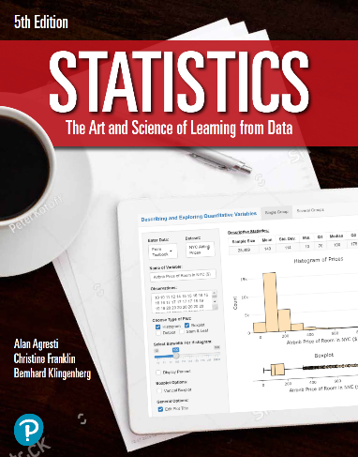

***“Statistics: The Art and Science of Learning from Data”***

**by Agresti, Franklin and Klingenberg, 5th edition**

**Chapter 12**

**Example 6: Predicting Max Bench Press – 95% Confidence Interval for the Slope**

## Reading in data

data <- read.csv(file='https://raw.githubusercontent.com/artofstat/data/master/Chapter12/highschool_female_athletes.csv')  
colnames(data) #check column names

## [1] "Athlete" "BP60" "maxBP..lbs."   
## [4] "LP200" "maxLP..lbs." "Situps..per.minute."  
## [7] "X40YD..sec." "VerticalJump..in." "SitReach..in."   
## [10] "MB..in." "SR..sec." "Age"   
## [13] "Height..in." "Weight..lbs." "Bodyfat...."   
## [16] "BMI" "Sport"

# Fitting regression model

lin.reg <- lm(maxBP..lbs. ~ BP60, data = data)

# To compute a 95% confidence interval for the slope, you can use the confint() function

confint(lin.reg, 'BP60', level = 0.95)

## 2.5 % 97.5 %  
## BP60 1.190987 1.791119